Purpose
This document defines the end-to-end process for generating, validating, and reconciling the VAT Avalara Sales Tax Report. It is intended to be used by Zalos to design and configure an automated agent that accepts Avalara exports and produces a standardized VAT workbook with reconciliation checks.
The process reflects current operational practice used by Accounting and incorporates required validation logic, reconciliations, and exception handling.

Inputs

1. Avalara – Sales Tax Document Line Detail (Primary Input)
Source: Avalara
Report Category: Sales tax document data export
Report Name: Sales Tax Document Line Detail
Run Parameters: - Period: Previous month (single month) - Country: All Non-US - Region: All - Output Format: .XLSX
Key Columns Used: - Tax Amount (primary metric) - Line Amount (used for variance / sanity checks) - Tax Name - Country - Currency Code – Document date

2. Daily FX rates
Source: GDrive – Fin25 report
Purpose: daily fx rates to convert our transactions into USD
Key Column Used: - Amount Due to Avalara

3. VAT Avalara Sales Tax Report (Previous Reconciliation report)
Source: GDrive
Purpose: To compare prior figures with the current reconciliation report.
Key tab Used: - PIVOT, EU Countries

Process Overview
- Extract raw transactional VAT data from Avalara
- Validate and convert the data to USD
- Summarize Sales and VAT liability by Country
- Convert so that it matches the GL
- Produce final summary output used for booking and review

Detailed Process Steps

Step 1: Currency Validation Check (Critical Control)
Objective: In the SalesTaxDocumentLineExport file ensure all transactions do not = US and convert transactions to USD
- Add a column for the formula date: CONCATENATE(TEXT(J2,"m-dd-yyyy"),"-",P2)
To concatenate DOCUMENTDATE and CURRENCYCODE
- In the following column add a column labeled FX Rate
VLOOKUP(BK2,'NS Daily FX Rates'!$A:$B,2,FALSE)
- In the following column add label USD Sales Amount
Formula: BL2*AE2 (FX Rate * Lineamount)
- In the following column add label USD Tax Amount
Formula: BL2*AM2 (FX Rate * Taxamount)
- In the following column add label EU Countries
Formula: FERROR(VLOOKUP(A2,'EU Countries'!$A$3:$B$30,2,FALSE),"")
Output: - Flag indicating any transactions occurring in the COUNTRY US and flag any countries without an FX

Step 2: Generate Pivot for Sales Tax Document Line Export
- Insert – Pivot Table
- Use the following Field lists (Pivot table configuration showing Country and Currency Code as rows, with aggregated USD Sale Amount and USD Tax Amount in values.)
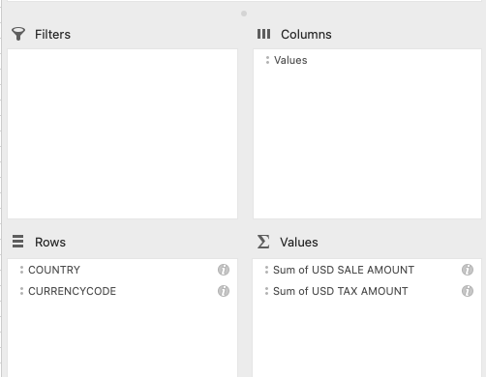
- In Column F paste the previous month’s generated Pivot in the PIVOT (CURR) tab
- Name the tab “PIVOT (CURR)

Step 3: Generate another Pivot for Sales Tax Document Line Export
- Insert – Pivot Table
- Use the following Field lists (Pivot table setup with **Document Status** as a filter, **Country** as rows, and aggregated **USD Sale Amount** and **USD Tax Amount** in values.)
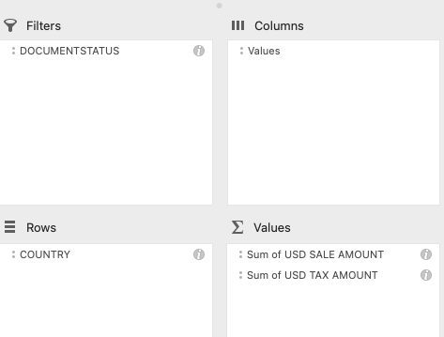
- In Column H paste the previous month’s generated Pivot in the PIVOT (Summary) tab
- Under the newly generated pivot add a new pivot with the following filters
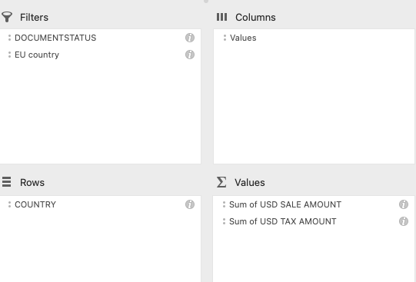
- In the EU country filter, unselect the blank field
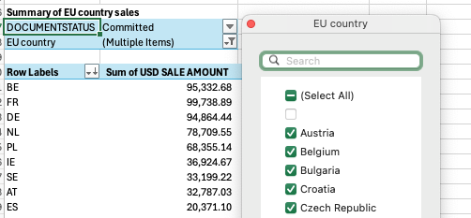
- In column H paste the corresponding pivot that was generated in last months report.

Step 4: Copy Sales tax, remove non tax entries, Pivot – Pivot Table
- Copy tab SalesTaxDocumentLineExport-ALL to a new tab
- In the tab, exclude transactions where EXEMPTREASON = “Customer is exempt. Does not have nexus in state.”
- Generate a pivot with the following fields
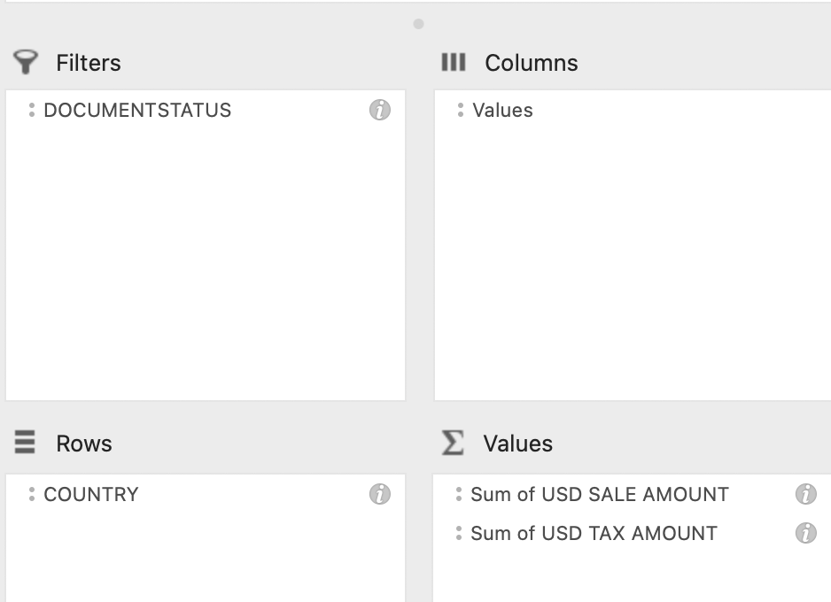
- DocumentStatus = Commited
- Below is the Country codes and corresponding GL account:
AU → 20731 – Australia
CA → 20732 – Canada
CH / LI → 20734 – Switzerland & Liechtenstein
GB / IM → 20736 – UK & Isle of Man
EU Countries → 20735 – European Union
AT BE BG HR CY CZ DK EE FI FR DE GR HU IE IT LV LT LU MT NL PL PT RO SK SI ES SE
PH → 20737 – Philippines
- In column E I want you to add a section where we can summarize the pivot by GL code:
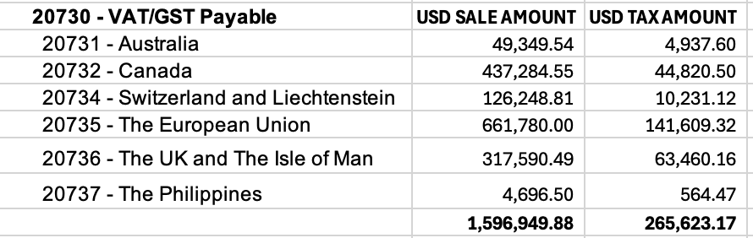
- Name the tab AVALARA SALES TAX DETAIL-ALL

Outputs

Primary Outputs
- Country-Level VAT Summary (USD)
  - Sales (USD)
  - VAT Liability (USD)
- GL Reconciliation Summary
  - VAT Liability summarized by GL code
  - Total VAT (USD)
  - Tie-out to Avalara export total
- Month-over-Month Comparison
  - Current vs Prior Month VAT (USD)
  - Variance by Country
  - Variance %
- Clean VAT Detail Dataset
  - USD converted
  - Non-tax excluded
  - GL-mapped

Flags / Exceptions
The agent must clearly identify and report:
- Transactions with Country = US
- Missing FX rate
- FX lookup failure
- Exempt transactions removed
- Countries not mapped to GL
- Variance between:
  - Pivot total USD Tax Amount
  - Raw dataset total USD Tax Amount

Automation Requirements for Zalos Agent
The agent must be able to:
- Accept Avalara VAT export and FX rate files.
- Convert all transactions to USD using a deterministic date + currency FX lookup.
- Validate country population (exclude US) and flag missing FX rates.
- Exclude exempt transactions automatically.
- Map countries to the correct GL accounts using a predefined mapping table.
- Generate structured summaries:
  - Country-level VAT (USD)
  - EU VAT summary
  - GL-level VAT summary
  - Month-over-month variance analysis
- Produce an exception report with clear reasons for each flagged item.
- Maintain a complete audit trail of source totals, exclusions, conversions, and final outputs.

